34.105: a) From the diagram below, we see that 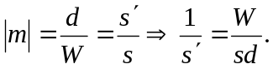
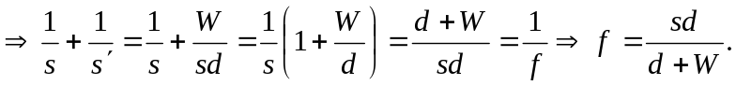 But when the object is much larger than the image we have the approximation:
2arctan 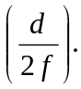
b) The film is so the diagonal length is just:
